INTELLIGENCE OF BIOLOGICAL SYSTEM 1[19BIO103]

S1 B. TECH CSE (AIE)

**AI IN CANCER**

A Project Report

*Submitted b*y

ROLL NUMBER NAME

1. AM.EN.U4AIE21138 Karthik G Nair
2. AM.EN.U4AIE21151 R Aravind
3. AM.EN.U4AIE21167 Vishnu Shaji
4. AM.EN.U4AIE21108 Akhilesh
5. AM.EN.U4AIE21181 Mamidi Sowji Krishna

**

AMRITA SCHOOL OF ENGINEERING

AMRITA VISHWA VIDYAPEETHAM

AMRITAPURI 690 525

January 2022

**ABSTRACT**

Judgement, as one of the center tenets of medicine, is predicated upon the combination of multilayered information with nuanced choice making. Cancer gives a completely unique context for clinical choices given now no longer simplest its variegated paperwork with evolution of sickness however additionally the want to remember the person situation of patients, their capacity to get hold of remedy, and their responses to remedy. Challenges continue to be withinside the correct detection, characterization, and tracking of cancers notwithstanding stepped forward technologies. Radiographic evaluation of sickness maximum normally is predicated upon visible evaluations, the interpretations of which can be augmented through superior computational analyses. In particular, synthetic intelligence (AI) guarantees to make outstanding strides withinside the qualitative interpretation of most cancers imaging through professional clinicians, inclusive of volumetric delineation of tumors over time, extrapolation of the tumor genotype and organic direction from its radiographic phenotype, prediction of scientific outcome, and evaluation of the effect of sickness and remedy on adjoining organs. AI can also additionally automate techniques withinside the preliminary interpretation of pix and shift the scientific workflow of radiographic detection, control choices on whether or not or now no longer to manage an intervention, and next commentary to a but to be expected paradigm. Here, the authors evaluate the modern-day nation of AI as carried out to clinical imaging of most cancers and describe advances in four tumor types (lung, brain, breast, and prostate) to demonstrate how not unusualplace scientific troubles are being addressed. Although maximum research comparing AI packages in oncology to this point have now no longer been vigorously established for reproducibility and generalizability, the consequences do spotlight an increasing number of concerted efforts in pushing AI generation to scientific use and to effect destiny instructions in most cancers care

**TABLE OF CONTENTS**

Content PAGE NO-

1. Introduction 4
2. Components Required 5
3. Circuit Diagram 6
4. Working of the system 7-11

1. Result 12
2. Conclusion 13
3. Code used 14-17
4. References 18

**INTRODUCTION**

Cancer, as a self-maintaining and adaptive system that interacts dynamically with its microenvironment, keeps to thwart patients, researchers, and clinicians in spite of great development in knowledge its organic underpinnings. Given this complexity, dilemmas rise up at each level of most cancers management, which includes dependable early detection; correct difference of preneoplastic and neoplastic lesions; willpower of infiltrative tumor margins at some point of surgical treatment; monitoring of tumor evolution and capability received resistance to remedies over time; and prediction of tumor aggressiveness, metastasis pattern, and recurrence. Technological advances in clinical imaging and minimally invasive biomarkers preserve promise in addressing such demanding situations throughout the spectrum of most cancers detection, treatment, and monitoring. However, the translation of the huge extent of records this is generated through those improvements provides a barrage of recent capability demanding situations.

As we examine greater approximately the sickness itself, we're mastering greater approximately the energy of gear which might be already to be had to us, which can be utilized in unparalleled ways. When a neoplastic lesion is first of all detected, it desires to be prominent from nonneoplastic mimickers and labeled primarily based totally on its expected medical direction and organic aggressiveness to optimize the kind and depth of remedy. The substantial availability of computed tomography (CT) and magnetic resonance imaging (MRI) have fueled the incidental detection of lesions in the frame with doubtful medical significance, which then initiates a cascade of observation, similarly testing, or empiric intervention. With remedy, which incorporates cytoreduction thru surgery, elicitation of direct and oblique mechanisms of tumor kill thru radiation, and pharmacotherapies, cancers may also adapt to the stressors imposed, evolve, and recur. With the radiographic look of a lesion that will increase in length after remedy, difference must be made among neoplasm or tissue reaction to injury. On recurrence, neoplastic lesions had been proven to harbor new molecular aberrations awesome from the number one tumor, which may also confer resistance to clinical or radiation therapies. This is compounded through the innate intratumoral heterogeneity of cancers on the time of preliminary diagnosis, that's an increasing number of validated through studies however tough to seize in ordinary medical pathological sampling and profiling. The call for for noninvasive imaging, because the maximum not unusualplace approach to tune reaction to remedy and to indicate crucial facts approximately tumors themselves, has in no way been greater.

## **AI APPLICATIONS IN CANCER IMAGING**

Within most cancers imaging, AI reveals high-quality software in acting three predominant medical tasks:

* Detection,
* Characterization,
* Tracking of tumors.

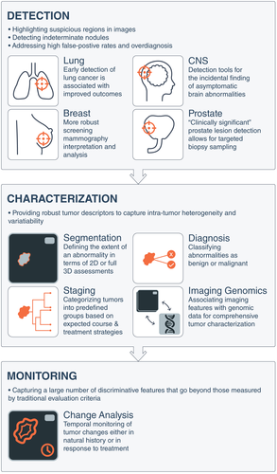

Artificial Intelligence Applications in Medical Imaging as Applied to Common Cancers. Artificial intelligence tools can be conceptualized to apply to 3 broad categories of image-based clinical tasks in oncology: 1) detection of abnormalities; 2) characterization of a suspected lesion by defining its shape or volume, histopathologic diagnosis, stage of disease, or molecular profile; and 3) determination of prognosis or response to treatment over time during monitoring. 2D indicates 2-dimensional; 3D, 3-dimensional; CNS, central nervous system.

**THE PROCESS**

* Characterization extensively captures the segmentation, diagnosis, and staging of tumours. Segmentation defines the quantity of an abnormality.
* In current clinical practice, tumours are typically manually defined, with associated limitations including interrater bias, inconsistent reproducibility even among experts and consumption of time and labour. AI has the potential to increase the efficiency, reproducibility, and quality of tumor measurements dramatically with automated segmentation. Finally, with the rapid expansion of computing speed and the increased efficiency of AI algorithms, it is likely that future analysis of cancer lesions will not require a separate segmentation step, and whole-body imaging data could be evaluated directly by AI algorithm. By comparison, computer-aided diagnosis (CADx) systems use the systematic processing of quantitative tumour features, allowing for more reproducible descriptors.
* CADx systems have been used to diagnose lung nodules in thin-section CT15 as well as prostate lesions in multiparametric MRI, in which inconsistencies in interpretation among human readers have been observed. Characterization also includes staging, in which tumours are classified into predefined groups based on differences in their cancer`s appearance and spread that are informative for the expected clinical course and treatment strategies. Recent studies have extended systems to perform staging by assessing tumour extent and multifocality in breast MRI, whereas others have developed automated lesion volume measurement tools in contrast-enhanced magnetic resonance mammography (MRM). The emerging field of “imaging genomics” correlates radiographic imaging features with biological data, including somatic mutations, gene expression, chromosome copy number, or other molecular signatures.
* Traditional temporal monitoring of tumors often has been limited to predefined metrics including tumor longest diameter measured through the established Response Evaluation Criteria in Solid Tumors (RECIST) and World Health Organization (WHO) criteria for estimating tumor burden and determining treatment response. In addition to being criticized as oversimplifying the complex tumor geometry captured through sophisticated imaging instruments,the generalizability and efficacy of such criteria have been questioned, as in the case of osseous lesions, for which chemotherapy—which has proven to improve survival—does not result in radiographic responses as measured by RECIST. AI-based monitoring, however, is able to capture a large number of discriminative features across images over time that go beyond those measured by human readers.

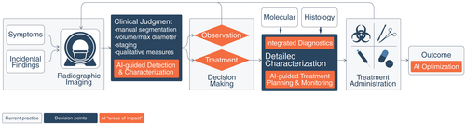

**LUNG CANCER IMAGING**

Lung cancer is a leading cause of cancer-related death among men and women globally.Despite improvements in survival over the last several decades for most cancer types, lung cancer is falling behind, mainly because the cancer is often well advanced, with limited treatment options by the time it is detected.

The finding that the majority of patients who are diagnosed with lung cancer will die from their disease can be attributed to the late stage at diagnosis. Medical imaging and AI are expected to play an important role in improving the early detection and characterization of lung cancer by differentiating benign from malignant nodules. Because early stages are often curable, this could drastically improve patient outcomes, minimize overtreatment, and even save lives.

### **Clinical Applications of AI in Lung Cancer Screening.**

Until recently, a technique to locate early-level lung most cancers has been elusive even amongst high-danger populations. The National Lung Screening Trial (NLST) proven that screening with low-dose CT (LDCT) changed into related to a tremendous 20% discount in standard mortality amongst high-danger present day and previous smokers. Although the NLST demonstrated a clear benefit for reducing all-cause mortality, many limitations are associated with the early detection of lung cancer that could be enhanced with advanced computational analyses.

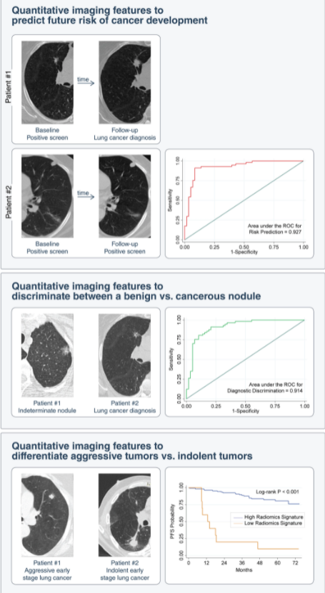

Clinical Applications of Artificial Intelligence in Lung Cancer Screening on Detection of Incidental Pulmonary Nodules. Imaging analysis shows promise in predicting the risk of developing lung cancer on initial detection of an incidental lung nodule and in distinguishing indolent from aggressive lung neoplasms. PFS indicates progression-free survival; ROC, receiver operating characteristic

**CNS TUMOUR IMAGING**

CNS tumors span a broad spectrum of pathologies, and perhaps are more diverse than tumors of any other organ system in the body. Among tumors arising from or seeding in brain parenchyma, metastases from systemic cancers and gliomas predominate. In addition, a multiplicity of tumors arising from non-neural tissues that abut the brain are commonly encountered and must be considered within CNS tumors, including meningiomas, pituitary tumors, schwannomas, and lesions of the skull. This variegated diorama of diagnoses poses unique demands on clinicians for the accurate assessment of imaging.

Three primary demanding situations presently exist for the duration of the assessment of radiologic research for CNS tumors:

1) correct analysis of the sort and volume of sickness is tantamount to medical selection making;

2) dependable monitoring of neoplastic sickness over time, particularly after remedy with its related results on surrounding neural tissue, which may also accumulate sign traits tough to differentiate from tumor;

3) the capacity to extract genotype signatures from the phenotypic manifestation of tumors on imaging, because the effect of molecular taxonomy turns into more and more more liked in influencing tumor conduct and medical outcome.

******************